Tensorflow supports python version greater than 3.7 and less than 3.10, latest version of python is not allows to install tensorflow library. For TensorFlow 2.18.0, the recommended Python version is **Python 3.8-3.10**. TensorFlow 2.18.0 officially supports Python 3.8, 3.9, and 3.10, but Python 3.9 is generally a good balance between compatibility and newer features.

So, if you're setting up a new environment, you can use **Python 3.9** for the best compatibility with TensorFlow 2.18.0.

**STEPS:**

1. Create virtual environment

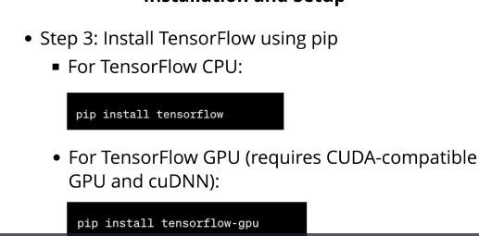

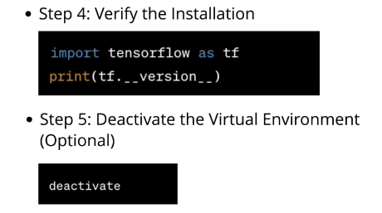

**STEPS TO INSTALL GPU TENSOR**

Installing this will accelerate the deep learning model training, it trains deep learning model more faster way.

